Game Design Document

Fill up the Following document

Gurram Janakiram NagaVenkata Sai

1. Write the title of your project.

Treasure rush

1. What is the goal of the game?

To show that life is full of problems ,we should find it’s solution by ourself.

1. Write a brief story of your game?

A prince /king got a task to find the treasure at the end of their kingdom.

Our hero needs to find the treasure’s key among 3 keys and unlock the box.

His path will be full of venomious snakes and scorpions.hero gets a chance to use sword in his way to kill the enimies.

1. Which are the playing characters of this game?

* Playing characters are the ones which respond to the user based on the input from the user
* Cars, monkeys, dinos, wizards etc, are the playing characters in the game.

|  |  |  |
| --- | --- | --- |
| Number | Character Name | What can this character do? |
| 1 | King/prince | Kills enemies and find’s treasure |
| 2 |  |  |
| 3 |  |  |
| 4 |  |  |
| 5 |  |  |
| 6 |  |  |
| 7 |  |  |
| 8 |  |  |

1. Which are the Non Playing Characters of this game?

* Non Playing characters are the ones which don't have an action or a behaviour when the user interacts with the game.
* Hurdles, stones, bananas, coins, etc are non playing characters in the game.

|  |  |  |
| --- | --- | --- |
| Number | Character Name | What can this character do? |
| 1 | Sword | Give’s power to the king/prince. |
| 2 | key | Give’s power to open the box |
| 3 | Treasure box | Give’s the power to increase wealth and gold in his kingdom |
| 4 | snakes | Kill’s king /prince by releasing venom |
| 5 | spiders | Release venom to kill prince/king |
| 6 | scorpions | Kill’s king/prince by releasing venom |
| 7 |  |  |
| 8 |  |  |

Draw your imagination of this game. What does this game look like?

* Draw the game either on your computer or on paper,
* Add images of scenes of the game to show each of the playing and non-playing characters at least once.

[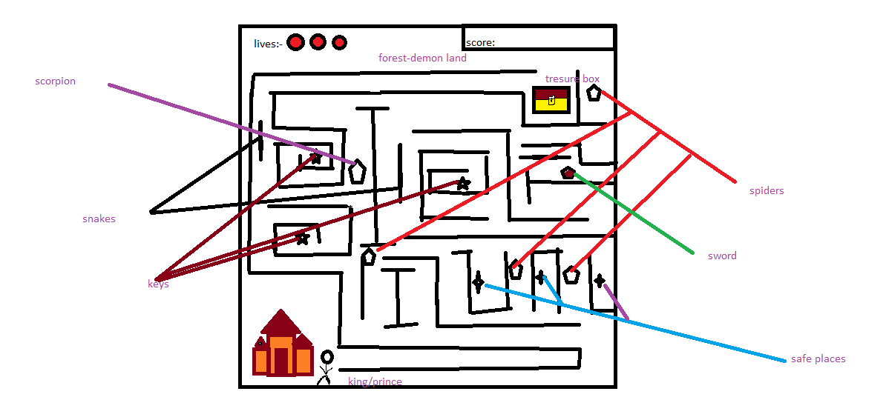](my%20gam.docx)

How do you plan to make your game engaging?

1.By giving him/her equal power of enemies at certain time to make them engaging.

2.Very thrilly challenges are in volved to make it fun filled.

3.Player even has some safe places to find himself/herself.